Lab exercise
This exercise is about structuring information with HTML and applying styles and layout using CS..
What you see here is a tribute page to the best holiday you have ever had.
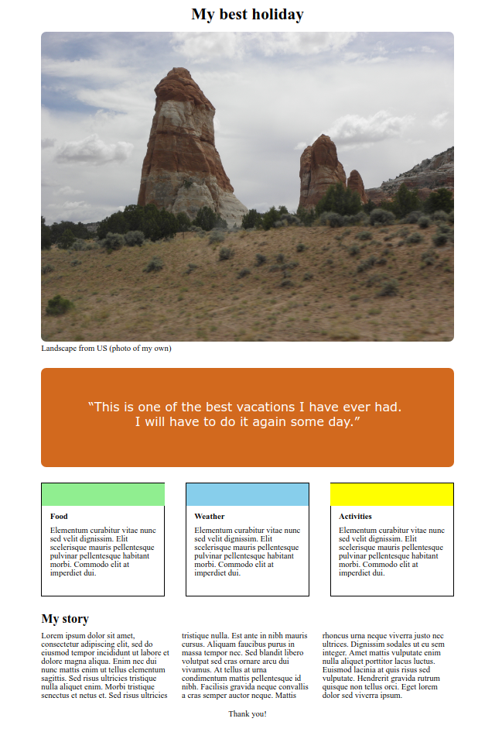
The page has:
- A <h1> heading “My best holiday”
- A mood picture from the best holiday. Maybe you have one on your smartphone you can use?
- A quote
- Cards that are placed in a flex box. Each card describes key points from the holiday.
- A <h2> heading “My story”.
- A paragraph that has columns as its inner display. This section describes the holiday in more detail.
- A “thank you” paragraph

Your task is to:
- Go to the start folder and open the index.html to see, what I have already prepared for you.
- Link the HTML to the external stylesheet.
- Give the HTML elements the appropriate CSS style by creating the CSS rules and attach these rules to the HTML elements using the class selector.
You see my CSS specifications on the next page.

Remember to make a link from the HTML document to the CSS document.
Make the CSS rules from the following specifications and attach them to the appropriate HTML element following these descriptions:

The <h1> heading “My best holiday”
The heading has a top margin set to 15 pixels and is centered.

The mood image
The image is displayed as a block element. Its width is set to 100% and it is centered using margin: 0 auto. Its border-radius is 10 pixels to make smooth corners.

The quote
The quote is displayed as a block and its font size is 1.5rem. Its font belongs to the Verdana, Geneva, sans-serif family. I have used padding to align the quote vertically so I have set the padding to 60px. The quote is also centered horizontally. The text color is white. The height of the element is 192px and the margin top and bottom is both 30 pixels. Its border-radius is 10 pixels to make smooth corners.

The cards placed in a flex box
The cards have the same style as shown in previous examples. The colors are lightgreen, skyblue and yellow. The flexbox has justify-content set to space-between and flex-wrap is set to wrap;

The <h2> heading “My story”.
It has a margin top of 30px and a margin bottom of 10px.

The columns paragraph
It has the maximum column width set to 250 pixels.

The “thank you” paragraph
Its text is centered with a top and bottom margin of 20px.

